Day 19 : 22 Nov 2024 CB FSD - Planning and UI Design

Angular CLI (Command Line interface) which help to create angular project template.

npm install -g @angular/cli@16.0.1

ng version

create separate folder as angular programs

syntax to create the angular project

ng new project-name

ng new welcome-app

routing -🡪N

styling 🡪css

after project creation done. We need to move inside a project folder using cd command.

cd welcome-app

to run the angular project we need to run the command as

ng serve -open

or

ng serve -o

then it will compile the project and after compile it will open in your machine default browser with URL as

<http://localhost:4200>

open the project in VS code

then

src 🡪 app

app.component.html

(in angular html file is known as template file. Inside this file we can do some dynamic coding).

app.component.css

app.component.ts

angular use few decorator.

Decorator : it is a type function which help to apply special behaviour of class or function. Decorator also known as meta-data. Data about data. Angular created lot of pre-defined decorator to apply special behaviour for class.

Like @Component, @NgModule, @Injectable, @Input,@Ouput, @Pipe etc.

Component is use to control the view or part of view of web page.

@Component decorator contains few attribute

selector : using this attribute we can create user defined tag. templateUrl: this attribute is use to connect html page.

styleUrl: this attribute is use to connect css file like link tag in normal html.

app.module.ts

modules : is a collection of component, service, pipe or other file.

@NgModule decorator :

Attribute for NgModule decorator

declaration : in this section we need to provide all component details.

imports : we can import pre defined or user defined modules.

BrowserModule : this module help us do display .ts file code on browser.

Providers : inside this section can provide angular service class details.

bootstrap : this section provide use parent component to load initially.

Login module

SignIn 🡪like component

SignUp 🡪 like component

Customer module

Account module

index.html first page which contains our root component selector <app-root></app-root>

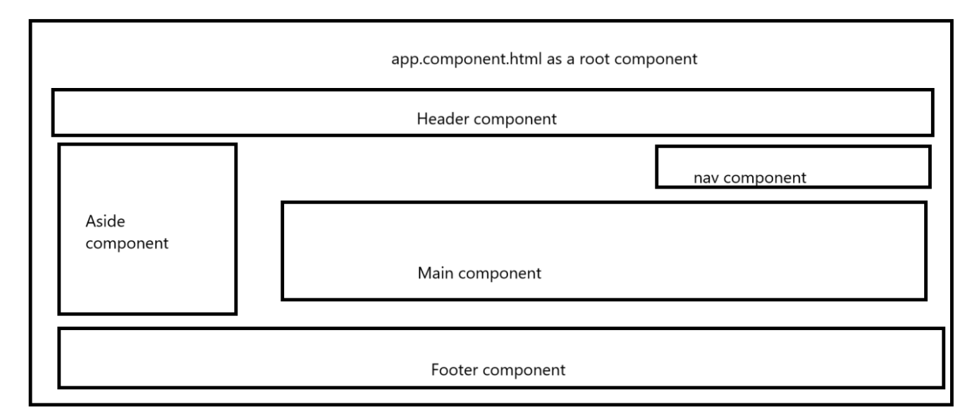

Using angular cli we can create user defined component

ng generate component componentname

Or

ng g c componetname

ng g c header

ng g c footer

data binding

data binding help use to share the data or variable between component to ts or vise-versa.

1. One way data binding
   1. String interpolation : it is type of one way data binding which help to share data between component to view

ts(component) ----------------🡪html page (view)

syntax

{{}}

{{variableName}}

{{10+30}}

{{functionName()}}

1. Two way data binding